
SEKOLAH TINGGI MANAJEMEN INFORMATIKA DAN KOMPUTER
(STI &K) JAKARTA

LABORATORIUM KOMPUTER

Nama Praktikan : Machfud Bagus S Nilai Paraf Asisten
NPM / Kelas : 10411130
TGL Praktek : 31 Oktober 2012
Materi Pertemuan Ke :
Mata Kuliah Praktikum : Pemrograman Web ( ) ( )

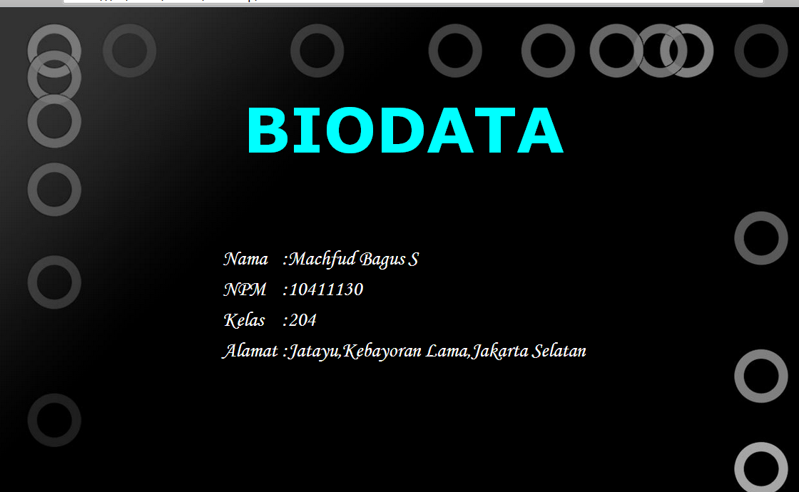

<html>
<Head>
<title>BIODATA</title>
</head>
<body background="satu.jpg">
<font color="aqua" face="verdana" size="8" align="center"> <br><h1>BIODATA</h1></br>
</font>
<table align="center" border="0" cellpadding="4" cellspacing="0">
<tr><td><font face="monotype corsiva" color="white" size=6>Nama</td>
<td><font face="monotype corsiva" color="white" size=6> :Machfud Bagus S</tr>
<tr><td><font face="monotype corsiva" color="white" size=6>NPM</td>
<td><font face="monotype corsiva" color="white" size=6> :10411130</tr>
<tr><td><font face="monotype corsiva" color="white" size=6>Kelas</td>
<td><font face="monotype corsiva" color="white" size=6> :204</tr>
<tr><td><font face="monotype corsiva" color="white" size=6>Alamat</td>
<td><font face="monotype corsiva" color="white" size=6> :Jatayu,Kebayoran Lama,Jakarta Selatan</tr>
</body>
</html>

